16th ANNUAL
“MFMA”
Stellantis ~ Dodge Presentation
Tuesday, October 3, 2023 ~ 8:00AM
Breakfast at Belvedere Banquets
1170 W. Devon at Rohlwing Road
Elk Grove Village, IL 60007
The Municipal Fleet Managers Association
Welcomes
Christopher Thomas ~ Great Lakes Government Sales Manager
Ryan Austin ~ Law Enforcement Program Manager
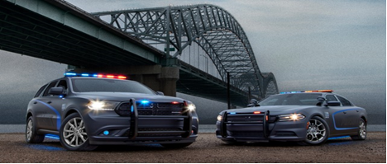
The presentation will be on the full lineup of 2024 Stellantis Company vehicles.
Q & A will follow the new vehicle presentation with emphasis
on police vehicle service related issues.
Product brochures will be available.
PAYMENT OF $35.00 @ IS REQUIRED IN ADVANCE
Contact Jack Gray at 224-588-6442 or jackgray500@att.net for more information.
Kindly send payment with the name of each attendee to:
MFMA c/o Jack Gray
8380 Bridgeport Bay Circle, Mount Dora, Florida 32757-8821

Reservations and payment must be received
no later than September 29, 2023.
Please, no payments will be accepted at the door.

