^{30th ANNUAL}
“MFMA”
General Motors Chevrolet Presentation
Tuesday, September 19, 2023 ~ 8:00AM
Breakfast at Belvedere Banquets
1170 W. Devon at Rohlwing Road
Elk Grove Village, IL 60007
The Municipal Fleet Managers Association
Welcomes:
Sean O’Shea~ Performance Manager-Police Vehicles – GM Envolve
Bernard Lackey ~ General Motors Fleet Services Manager-GM Envolve
MinDee Richey ~ Fleet Account Executive –GM Envolve
Kristin Hardison ~ Government Area Manager--GM Envolve
Note: Key Speaker Sean O’Shea-GM New Blazer EV PPV-Police Vehicle Manager
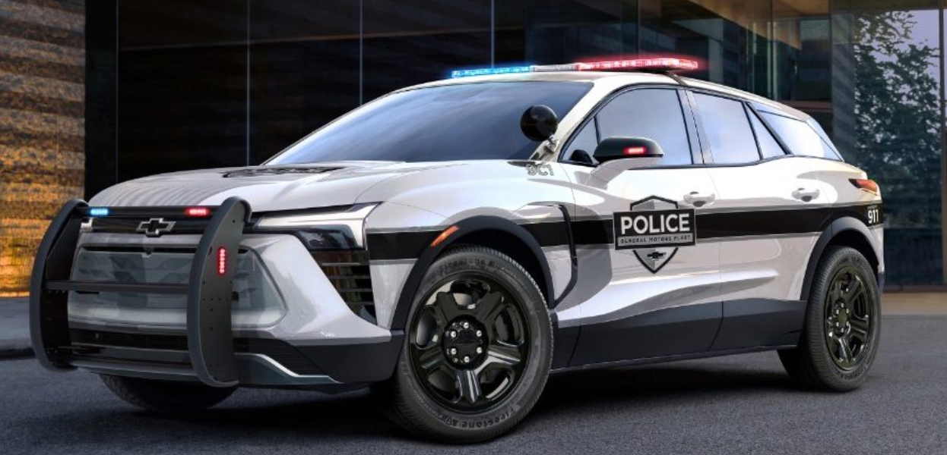
This presentation will have the latest possible information regarding the 2024 Police vehicle line up.
Possible vehicles on display: Tahoe PPV - Silverado SSV
Q & A will follow the presentation
with emphasis on police vehicle service related issues.
Product brochures will be available.
PAYMENT OF $35.00 @ IS REQUIRED IN ADVANCE
Contact Jack Gray at 224-588-6442 or jackgray500@att.net for more information.
Kindly send payment with the name of each attendee to,
MFMA c/o Jack Gray,
8380 Bridgeport Bay Circle, Mount Dora, Florida 32757-8821
Reservations and payment must be received
no later than September 15, 2023
Please, no payments will be accepted at the door.

